1. **Retrieve all students' information sorted by grade**

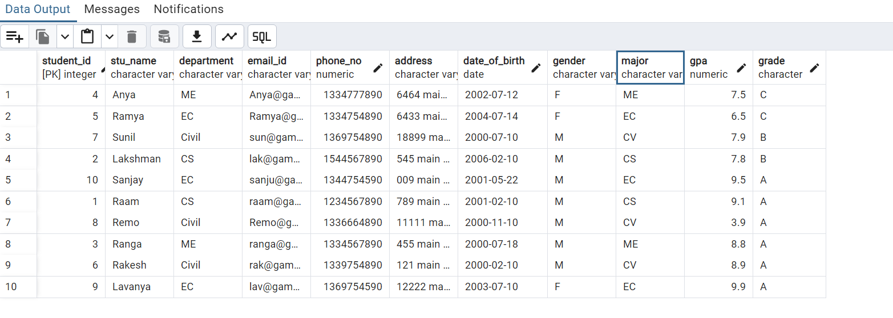

1. **Query for Male Students**

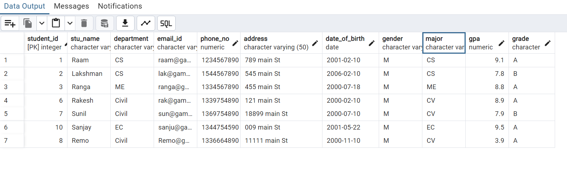

1. **Query for Students with less than 5 GPA**

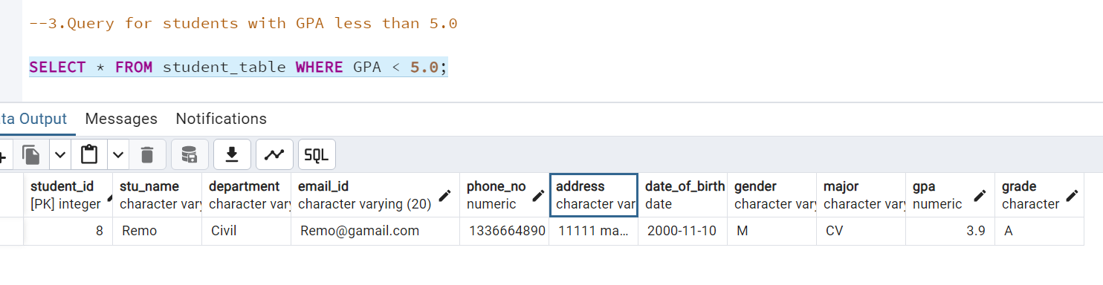

1. **Update Student Mail and Grade**

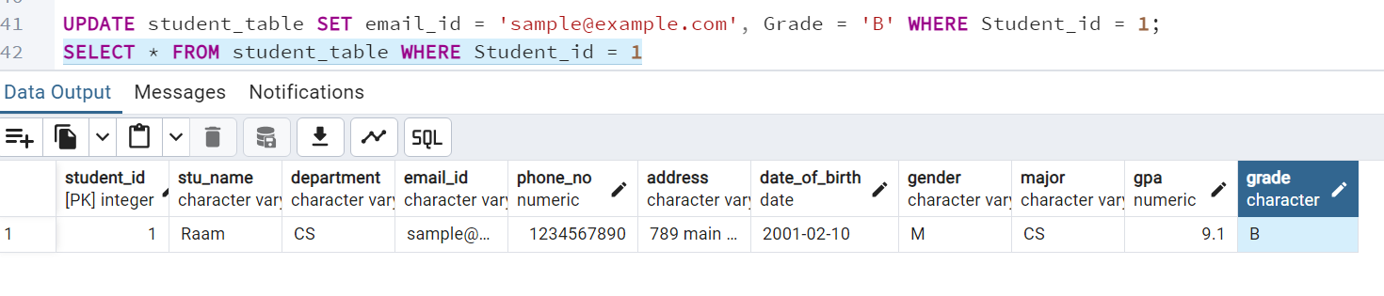

1. **Query for students with grade "B"**

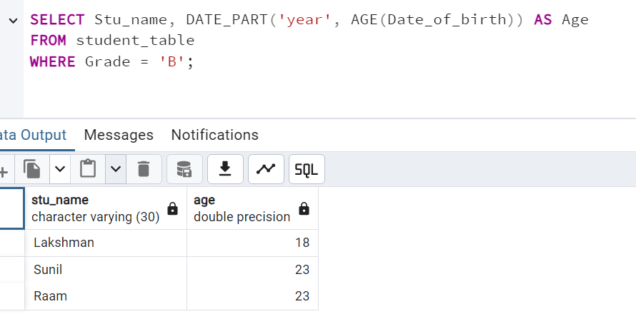

1. **Grouping & Calculation**

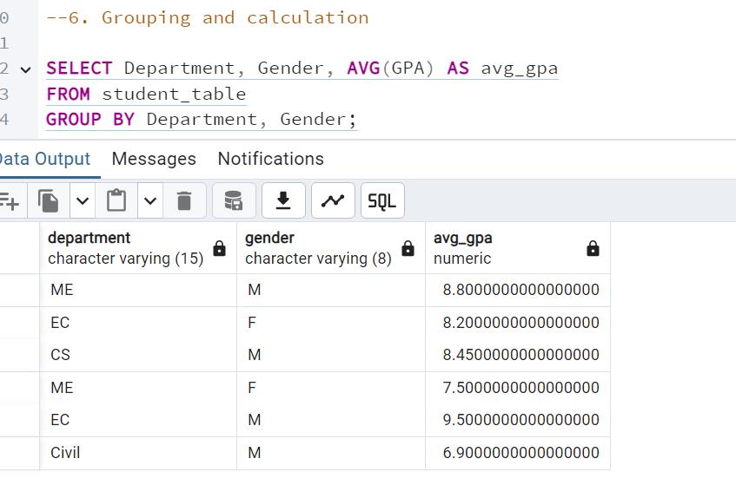

1. **Table name Renaming**

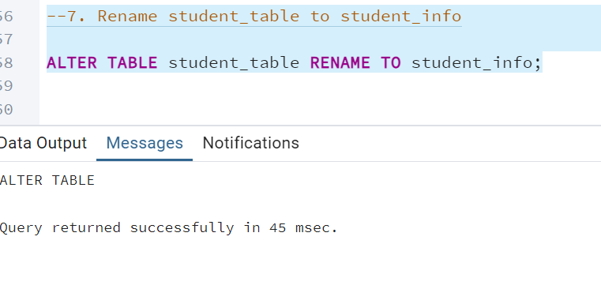

1. **Query to return Student with highest GPA from Student Info Table.**

